UK Plastics Pact Consultation: Eliminating Problem Plastics - REA’s DRAFT response
Before qu 8, questions are about the organisation that is answering the consultation.
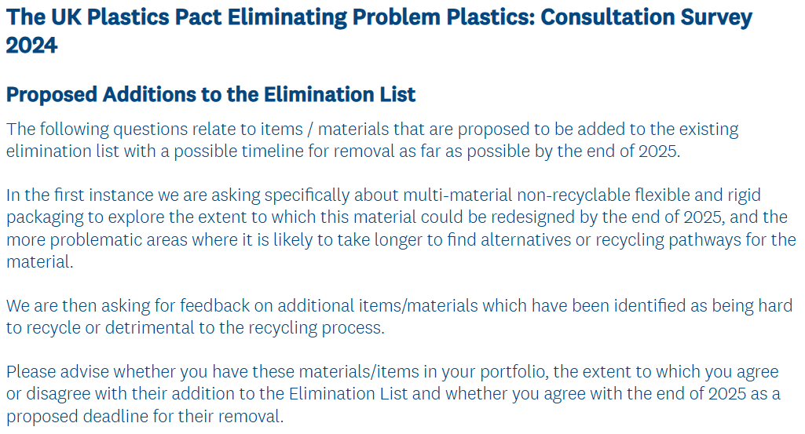
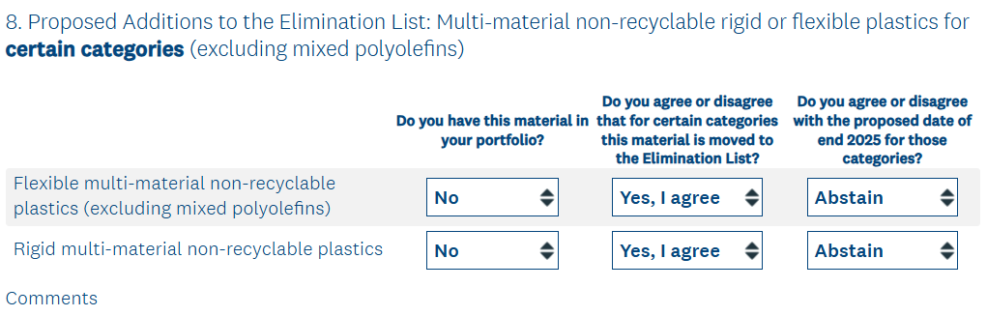
Text in the comments box:
We are a trade association. We do not trade these items and non-compostable multi-material non-recyclable rigid or flexible plastics are not in scope of our biowaste-relevant policy work, so we have answered that they aren’t in our portfolio. However, compostable items are within scope of our policy work and are traded by some of our members. Consequently, where this consultation’s questions are relevant to compostable items we have answered that this material is in our portfolio.
We assume the two descriptions in question 8 do not include compostable multi-material items. In the case of compostable multi-material plastics (and compostable items made of multi-materials that are not all compostable plastics, e.g. with some content as fibre), provided the whole product is certified compostable it can be organically recycled. Similarly, if the item consists of more than one component (a component is a product part that is easily separatable, e.g. by hand) and labelling is clear about which component is compostable and which component is non-compostable, the compostable component can be organically recycled.
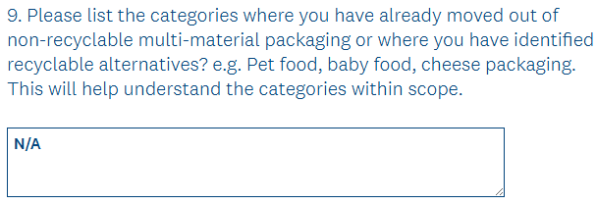
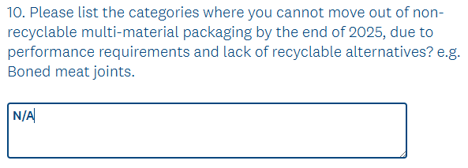
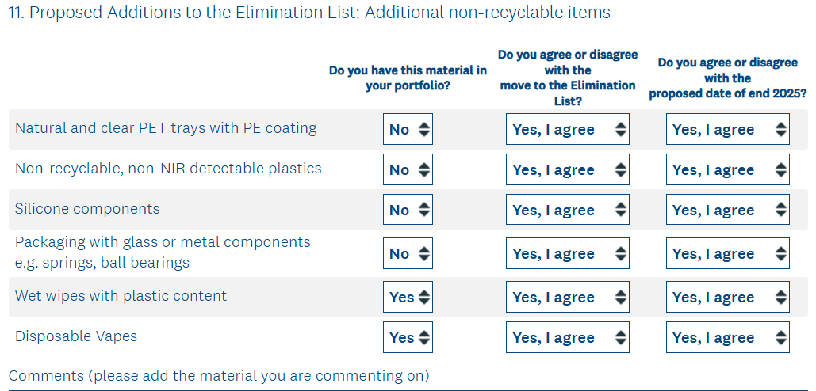
Text in the comments box:
We support elimination of non-recyclable, non-NIR detectable plastics, interpreting these as NOT including compostable plastics. The latter are organically recyclable and a number of compostable plastic types are detectable using NIR technology. We recommend WRAP contacts the Compostable Coalition UK for info on trials carried out in 2024 with MRF-relevant optical sorting machinery in ‘material analysis mode (NIR) only’. As the ‘bioplastic packaging’ trialled did not represent a huge amount of incoming waste, the trials were performed with ‘specific bioplastic detection settings’. In these trials, ‘bioplastic’ can be interpreted as compostable plastic.
In addition, hyperspectral imaging technology has achieved high detection accuracy rates for a range of compostable plastic types - see https://www.frontiersin.org/articles/10.3389/frsus.2024.1332163/full?&utm_source=Email_to_authors_&utm_medium=Email&utm_content=T1_11.5e1_author&utm_campaign=Email_publication&field=&journalName=Frontiers_in_Sustainability&id=1332163
REA supports elimination of wet wipes. For the purposes of the UKPP, it would help if they were more comprehensively defined and differentiated if and where necessary, e.g. according to different purposes for which they are sold and used. A current on-line definition of wet-wipes: 'a small disposable cloth treated with a cleansing agent, used especially for personal hygiene: "keep wet wipes on hand for use before and after snacks"'.
We interpret that kitchen roll is NOT the same as wet wipes. Compostable kitchen roll / sheets are useful in kitchens for clearing up food/beverage spills, for wiping up excess cooking oil or for absorbing cooking oil after frying food; they should not be used for any purposes where a chemical cleaning agent is added to the part of the roll / sheet being used. Info about an example product is at https://www.plenty.com/en/sustainability/compostable/

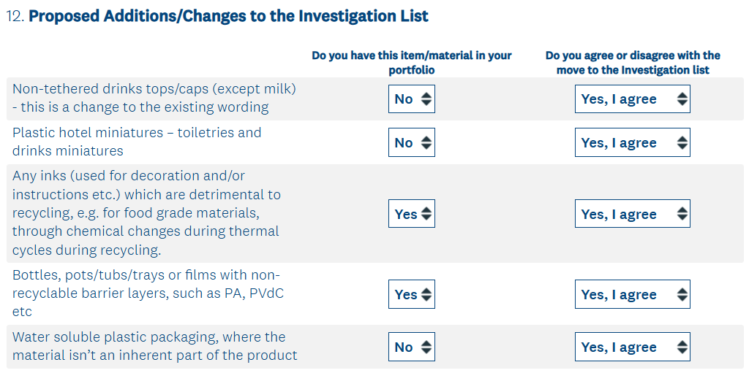
Text in the comments box:
Inks used for decoration and/or instructions etc which are detrimental to recycling, e.g. for food grade materials, through chemical changes during thermal cycles during recycling: we agree with moving these to the investigation list. Investigation of inks/pigments for compostable intermediate materials and finished products is unnecessary because standards for compostable packaging and non-packaging items already set limits for potentially toxic elements on/in the intermediate material or finished product; lab test results are evaluated as part of standards-compliance assessments carried out by certification scheme providers. In addition, at least some certification scheme providers carry out 'ink/pigment only' assessment and provide lists of 'registered' compostable inks/pigments.
Compostables: while use of inks for decoration purposes should be minimised, their use for communicating the product’s certified status and disposal guidance is essential unless it is suitable for embossing (but embossing can be difficult to read) or is a product format unsuitable to carry ink (e.g. a tea bag, in which case information on the outer packaging must convey the tea bag’s certified compostable status and disposal guidance).
Bottles, pots/tubs/trays or films with non-recyclable barrier layers, such as PA, PVdC etc: yes, these should be moved to the Investigation List. PVdC is known to negatively affect conventional thermal recycling of mixed plastics, e.g a PVdC coating on an oriented polypropylene film is known to make it non-recyclable. Its use should be avoided where there are alternatives that perform sufficiently well. There are a number of applications, including in the medical arena, where PVdC is used on its own or as part of a structure for critical moisture and gas barrier reasons. Care must be taken that any restrictions do not cause serious unintended consequences.
In the case of compostable films, a limited range of them use a small amount of PVdC to reinforce moisture barrier properties to protect moisture-sensitive products inside the packaging. As R&D develops at least some manufacturers are likely to reduce their use of PVdC in compostable films; for the time being this polymer type ‘remains valuable in widening the range of products that can successfully be packed by [the] customers’ of manufacturers. Quoting one company’s response: ‘All of these films have already passed the global standards for compostability and are certified as such. They will also be adjusted as may be required by any further revision of compostability standards. Therefore we would recommend that in the case of any compostable material it is the standards that guide the nature of the materials and not the requirements of other recycling technology. (Compostables are already far more regulated than conventional plastics in terms of environmental performance).’
A company has emphasised these points, with which REA agrees: ‘The drive for improved recyclability of plastics is tending to demonise mixed material formats, on the basis that the purer the recyclate stream the better. That is logical to a degree for conventional plastics. But it does not apply to compostables. A big advantage of compostables is that whether a compostable product is made of PLA, PBAT, PBS, starch, cellulose, any other compostable material or a mixture of compostable materials, it must meet a compostability standard. So if a product is made of mixed materials and meets a compostability standard its mixed materials content is not an issue. This is important because a number of known impossible-to-recycle food-contaminated structures such as stick-packs and condiment sachets are now being successfully developed in compostable solutions.’ (Stick-packs are streamlined, tube-like packaging primarily used for single servings of powders, granules and liquids.)
Water-soluble plastic packaging: our understanding is that a key application is bags for containing worn, washable/reusable medical garments used for caring for patients with infectious diseases and where washing the garments at hot temperatures would kill the disease-causing pathogens and enable the bags to dissolve into the grey water that exits the washing machines. Their use in relevant product formats and contexts of use - i.e. bags that enable washing of reusable medical garments - is relevant to risks an investigation would consider, as too would be assessing the efficacy of washing such garments in washable-reusable bags. It should be required that any packaging claimed to be water-soluble is clear about the relevant water context (e.g. in a washing machine above a specified minimum temperature) and has a valid certificate of compliance – issued by an independent certification scheme provider - with a pass/fail standard whose criteria include an aqueous biodegradation pass/fail criterion relevant to the setting/environment in which the product is designed to be used. Lastly, a similar point as made above about mixed materials being okay to use in a product provided it meets a compostability standard also applies to packaging that meets a standard for products that are soluble in water and biodegrade in water.
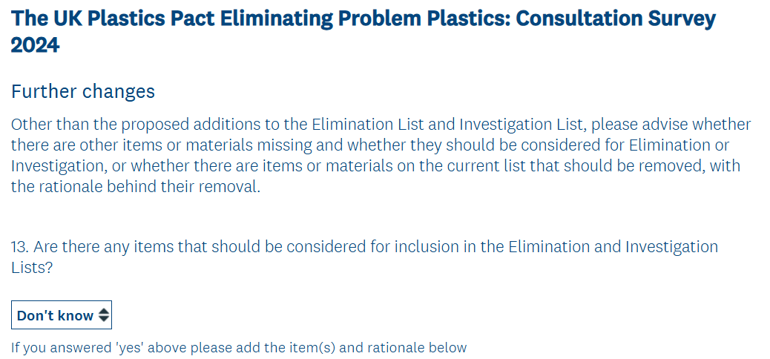
Text in the comments box:
Already on the Elimination List: 'Single-use, single-serving plastic sachets/jiggers in restaurant settings'. REA is supportive of replacing them with reusable alternatives where possible (e.g. jugs and dispensers at the point of purchase for takeaway), and where reusables are not practical redesigning this packaging for recyclablity or compostability and investing in infrastructure to enable recycling of non-compostable versions and/or organic recycling of compostable versions. Pathways for collecting and organically recycling compostable sachets/jiggers taken out with takeaway food need planning, e.g. street bin provision for compostables seems unlikely so they could potentially be disposed at home in local authority areas where food waste goes to an organic recycling facility whose feed-in policy includes compostable sachets/jiggers (provided rules on LA collections allow individual LAs to make their own decisions on what they allow to be collected co-mingled with food waste).
Thinking of use of compostable sachets and stick-packs used within any restaurants/cafes that cannot implement reusable containers / dispensers, Business-to-Business (B-2-B) arrangements may be feasible, e.g. their co-disposal with the restaurant's/cafe's food waste then being collected and in-vessel composted. As an alternative those sachets could be binned with other compostable packaging / food service ware used in restaurant/café (this approach might work for some fast-food serving businesses) and collected as a dry-ish waste stream for sending to the composting facility; this kind of waste stream is already being collected and sent to in-vessel composting under some B-2-B arrangements though REA does not have detail on whether used item formats include compostable sachets and/or stick-packs.

Text in the comments box:
Already on the Elimination List: 'Plastic packaging for uncut fresh fruit and vegetables unless it is demonstrated to reduce food waste'. Commenting on this, the 'unless it is demonstrated to reduce food waste' is important because highly perishable F&V such as raspberries, strawberries, blueberries and lettuces benefit from the protection provided by their packaging and this seems the only practical and time-effective way to sell the small, highly perishable F&V items. Compostable versions of packaging for F&V are available, e.g. compostable plastic film wrappers / packets / sleeves, compostable clingfilm, compostable fibre trays and compostable fibre-based composite trays and punnets; those that are compostable plastic should not be on the Elimination List, or if it is decided they are then the 'unless it is demonstrated to reduce food waste' caveat must be included. Our interpretation of fruit and veg is that this excludes herbs sold in pots and cut herbs sold in packets/wrappers.
Already on the Investigation List: 'Mono material flexible plastic packaging (e.g. crisps, fruit
and vegetable film packaging)'. Compostable plastic film wrappers / packets / sleeves and compostable clingfilm (e.g. https://www.novamont.com/eng/read-press-release/novamonts-new-mater-bi-cling-film-is-now-available/) should be considered as alternatives to non-compostable flexible plastic film packaging. For example, we hear that at least some cucumbers (whole or partly eaten) are discarded by householders in their plastic wrap. If such wrap were compostable, then where the food waste goes to 1) an in-vessel composting facility this wrap would biodegrade or 2) an AD facility this wrap would likely be removed during waste pre-treatment BUT as removal can be imperfect then any wrap pieces/fragments that get through pre-treatment have potential to biodegrade if the digestate is separated and the separated fibre digestate is aerobically matured (in a composting phase), as is allowed in PAS 110. Wholesale supply of fruit & veg: researching the extent of film packaging for these specific uses would be relevant to B-2-B arrangements for collection and organic recycling of fruit, veg and compostable film packaging wastes from business sources. Note that these wastes may be co-disposed by the business with other food and/or compostable packaging wastes.
Already on the Investigation List: 'Plastic cup lids (from hot beverage cups)'. Compostable cup lids used in conjunction with compostable hot drinks cups are a solution where B-2-B arrangements are in place between the premise where they are used (e.g. at a festival, sports stadium, office with inadequate space for washing and storing reusable cups, or 'fast-service' restaurant/cafe with a business model and/or premise-constraints that doesn't allow change to using reusable food service ware) and a suitable organics recycling facility (e.g. an in-vessel composting facility). Compostable cup lids should not be on the Investigation List.
Already on the Investigation List: 'Single-use plastic bags, including carrier bags and fresh produce bags'. WRAP's guidance encourages replacing them with reusable versions or to remove them if they are not required. The Co-Op's alternative approach is described at https://www.packagingnews.co.uk/news/plastics-news/co-op-bans-bags-life-calls-unified-approach-30-04-2021#:~:text=Co-op%E2%80%99s%20approach%20involves%20removing%20bags%20for%20life%20from,real%20reuse%20of%20bags%20in%20the%20retail%20setting and we assume WRAP has previously been supplied with the Co-Op's Bag to Rights policy document.
The REA believes compostable lightweight carrier bags can be beneficial if made available alongside reusable bags, priced at a lower price per unit than reusable bags and if a sufficient price is charged per reusable bag. The Co-Op's certified industrially and home compostable bags include print that communicates they can be reused as a 'food waste caddy liner' or 'kitchen compost bin liner', and not to put them in [bins for] 'plastic recycling'. They can also be re-used as carrier bags before a last use as food waste caddy liner or kitchen compost bin liner. Where they and the food waste they contain go to in-vessel composting this is as allowed in the Environment Agency's permit guidance and End of Waste rules and displaces non-compostable bags, and thus reduces risks of compost contamination by non-compostable plastics.
Where certified compostable carrier bags and the food waste they contain go to wet-AD facilities, those bags tend to removed during depackaging / bag-splitting machinery. As removal can be imperfect, our policy is that it is better to receive and imperfectly front-end remove certified compostable carrier bags than non-compostable ones; there is less risk of the digestate containing plastics that will persistent in the environment, more wet-AD facilities could aerobically mature separated fibre digestate (if they chose to separate whole digestate) or front-end removed certified compostable carrier bags could be sent for local treatment in an IVC facility (assuming they can be kept separate from non-compostable items at the AD facility). These points should be considered before deciding the UKPP policy on lightweight carrier bags.
Regarding fresh produce bags, the potential roles of certified industrially- plus home-compostable 1) very lightweight plastic produce bags, 2) paper bags and 3) composite materials bags should be considered for provision alongside reusable, thicker/more heavy-weight produce bags. How these different bags could be differently priced so that consumers mainly use reusable fresh product bags but can alternatively purchase compostable fresh produce bags when they forget to bring their re-useable ones or impulse-buy fresh produce should also be considered.
(Please note that where composite materials are used in a certified compostable finished product that has no easily separatable components, all the materials in the product are assessed for compliance with the compostability standard(s). Please also note that if a certified compostable product does have easily separatable components, claims about the product must be clear on whether each component is compostable. Guidance being developed by the Compostable By Design Platform strongly recommends that all easily separatable components of any product with more than one of them are certified compostable.)
Tests of organic recyclability of compostable packaging
Although the consultation does not ask about these tests, we have commented on two tests because we believe the issues are important. At https://www.wrap.ngo/resources/guide/design-guidance-recyclability-household-rigid-plastic-packaging 'The 5 tests of recyclability' are listed. Test 2: 'Is the packaging (or product) widely collected for recycling? (The OPRL threshold used is that more than 75% of local authorities collect the material for recycling).' We assume there are acceptable alternatives to the OPRL threshold because what has been quoted on WRAP’s webpage does not recognise B-2-B arrangements for collecting conventionally recyclable packaging nor compostable packaging. The 'widely collected' part of the test is a challenge for the organic recycling sector given geographical differences in treatment process types and whether those processes currently feed compostables into their biological treatment phase(s) or could in future if suitable changes were made. If a 'collected by 75 % of LAs' test were to be applied then only compostable product formats that are small or small+flexible (so tend to pass through shredders at composting sites and not be removed by depackagers at AD sites) and included in LA guidance for inclusion in food waste bins (i.e. tea bags, coffee bags and fruit & veg stickers) would be procurable/sellable/usable by the relevant stakeholders. Considering potential use of a wider range of food-contact compostable packaging in product formats and contexts of use where they aid sustainability and recyclability, there needs to be a suitable threshold for 'widely collected for organic recycling'; the threshold could gradually increase over time.
Unfortunately, if the applied threshold is as high as 75 % and especially if measured ONLY by what local authorities collect then ONLY an advance plan that has agreed implementation dates for starting to collect additional compostable formats in household food waste (or co-mingled food and garden waste) streams would work.
Test 3: 'Is the packaging (or product) capable of being sorted?' This is written with Dry Materials Recycling in mind and sorting of items at MRFs, PRFs and chemical recycling facilities. In the case of compostables collected co-mingled with food waste, co-mingled with food+garden waste or on their own as a dry-ish waste stream AND sent to a composting facility, sorting at the facility is not and would not be carried out, nor is it required. We acknowledge that composters carry out quality control checks on each load of waste delivered and take action to remove non-compostable items if their concentration is higher than what's stated in their waste acceptance criteria; however, they do not use machinery for identification and sorting of different types of packaging and non-packaging items.
At food-waste-fed AD facilities, current pre-treatment machinery does not sort compostable from non-compostable packaging and non-packaging items; such capability could in future be useful for back-of-food-retail-store waste streams that include a variety of material types in the packaging but it may not be necessary for wastes from sources where discarded packaging and/or food service ware items are targeting only compostable and there is a high rate of correct bin usage. Thus, for organically recyclable packaging and non-packaging products, Test 3 should be 'Is the compostable packaging or non-packaging product capable of being sorted, if the waste steam also includes significant content of non-compostable packaging or non-packaging product?'.

