**REA response to Defra’s RAM User Review on-line survey**

Deadline: 27 November 2024

Draft RAM Document V2:

<https://draft-origin.publishing.service.gov.uk/government/publications/recycling-assessment-methodology-materials-and-outputs?token=eyJhbGciOiJIUzI1NiJ9.eyJzdWIiOiIyNzg2ZGE2OS1iMjJlLTQ5YWYtODAxNC0xZjIzZTBjMzJjMmYiLCJjb250ZW50X2lkIjoiMTg1NTJhM2MtZTFlZi00ZGE0LTg3ODUtNGQ4ODUxMjBhMzFiIiwiaWF0IjoxNzMyMTIyNTUzLCJleHAiOjE3MzQ3MTQ1NTN9.T9MQMsSYb4sZmjvYrZj0PAcu_EP9m9Xfj2MgRNxf90c&utm_campaign=govuk_publishing&utm_medium=preview&utm_source=share>

Questions 1 to were about the organisation responding. REA’s response was submitted on 27th Nov 2024.

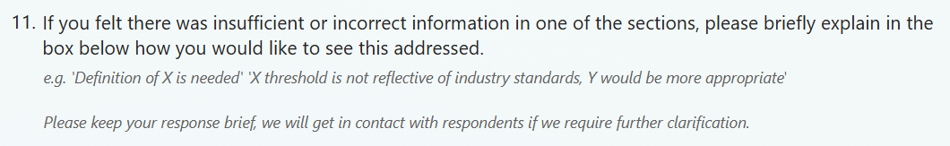

Text entered in box:

Needs a category 'fibre-based compostable composite packaging', unless all compostable packaging is given its own separate category in pEPR. It can be organically recycled (e.g. by in-vessel composting) via, for example, collection of fast-/convenience-food service plus compostable item wastes that arise at those business premises. The Take-Back Protocol requires 'Collection points must be available to at least 75% of the population': this okay for schemes involving organisations with nationwide (or near-nationwide) premises but the rule prevents businesses without such a network from providing a take-back scheme. Is it assumed that such businesses can make arrangements with partner organisations who have a large enough network of premises at which collection points can be installed? Where a business waste stream is compostable packaging collected with food waste, can the compostable packaging part of it count part of take-back scheme or does it count as a kerbside collection? And where a business waste stream is compostable packaging waste only, does this count as a take-back scheme (if it also serves a large enough % of the population) or is it a kerbside collection? Sortation, reprocessing and application parts of this guidance section should cover the different requirements applicable to organic recycling of compostable packaging. In all of REA’s answers ‘compostable’ means the packaging item is independently certified compliant with the standard EN 13432 or ASTM D6400.

[Info from source docs, for REA members’ awareness and not included in REA’s response: Take-back scheme guidance: ‘Collection schemes should not actively compete with kerbside collections or encourage consumers to use their system in place of kerbside collections.’]

~~

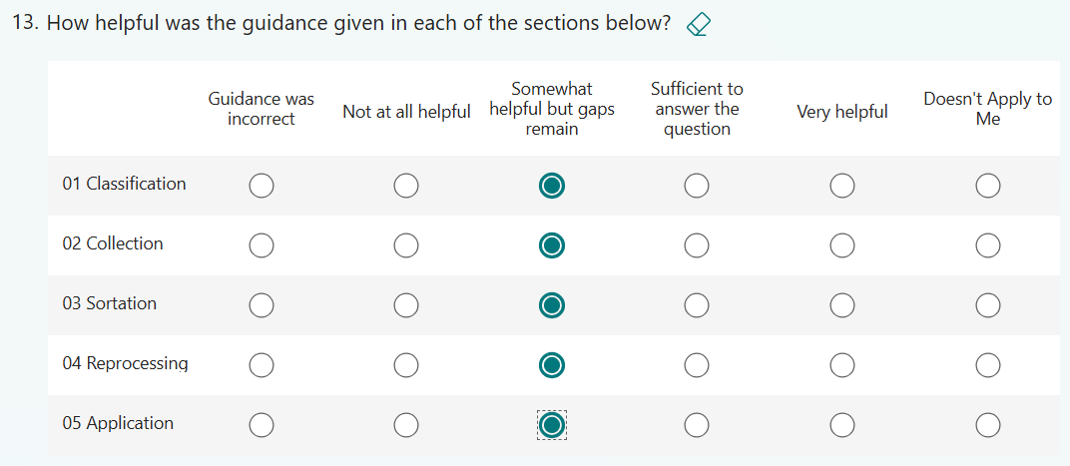



Text entered in box:

Needs a category 'Compostable Plastic (Flexibles)’ unless all compostable packaging is given its own separate category in pEPR. It can be organically recycled (e.g. by in-vessel composting) via, for example, collection of 1) food waste plus compostable food-service item wastes collections from premises that sell/serve fast-/convenience-foods or 2) compostable packaging taken back after selling fruit/veg/salad to consumers via a boxed-fresh-produce-to-door delivery. Example product formats are respectively compostable condiment sachets and salad bags. Where a business waste stream is compostable packaging collected with food waste, does the compostable packaging part count as a take-back scheme or is it a kerbside collection? Where a business waste stream is compostable packaging taken back after selling fruit/veg/salad to consumers via a boxed-fresh-produce-to-door delivery service, is it a take-back scheme (if it also serves a large enough % of the population) rather than a kerbside collection? Sortation, reprocessing and application parts of this guidance section should cover the different requirements applicable to organic recycling of compostable packaging.



Text entered in box:

Needs a category 'Compostable Plastic (Rigids)’, unless all compostable packaging is given its own separate category in pEPR. These can be organically recycled (e.g. by in-vessel composting) via, for example, collection of food waste plus compostable food-service item wastes collections from premises that sell/serve fast-/convenience-foods. An example product format is compostable disposable plastic cups for cold drinks. (Same questions about take-back scheme or kerbside collection ‘status’ of business source waste as included in the section on fibre-based composites.) Sortation, reprocessing and application parts of this guidance section should cover the different requirements applicable to organic recycling of compostable packaging.

Text entered in box:

Compostable packaging can be small-format packaging, while large formats such as pallets tend to go to wood recycling rather than composting and pallets’ fate would depend on whether they had been treated with preservatives. Standards for compostable packaging include products made of wood, and any additives on or in the packaging would be included as part of the certification body’s assessment of whether the wood packaging product complies with the standard (EN 13432). Compostable wood packaging would fit within a Compostable Packaging category.

[The survey did not include questions about ‘Other’ materials, even though this is a category in pEPR and there is a short section about it on the draft RAM guidance on which Defra was consulting.]

N/A given how REA answered qu 32.

